Sorry that you are experience issues with the online member application.

Here are the required fields for all applications. These fields are denoted by a red asterisk next to the field name.

Members only password : I manually verify this password so it does not have an impact on submission
Name :
Email :
Cell Number :
Alternate Number:
Address:
Committee of preference :
Waiver :
Signature :

[Fields with red box around it]
If you having an issue submitting, please review the form for any fields with a think red box around it. This is the field(s) that is preventing your from submitting your application

Here is an example

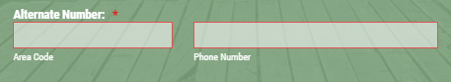

[Alternate Number]
We require this number because we need a way to contact you (your spouse) in case of emergency. If we are expecting you to meet at a certain location while commuting on a trip, we want to be able to check on your well-being if you are unusually late.

If you do not want to provide an alternate number or you do not have one, then provide the same number your provided for your cell number.

[Signature]

- Device with touch screen support : use your finger or your stylus to make your mark (signature).
- Windows with no touch screen support: Hold down the left mouse button and make your mark (signature). It’s the same process of selecting text in a document except you will be making your mark while your mouse cursor is over the signature portion of the application.
- MAC : I do not own a single MAC but I am sure they have a similar concept as Windows

Here is an example of a blank signature. The form will not submit if the signature is blank. You can use the clear link at the bottom right to keep trying until you are happy with the results
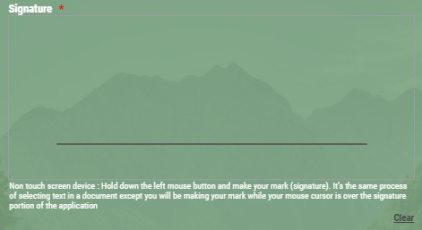

Here is an example with a signature provide. Your mileage will vary based upon the capabilities of other devices that you are using but you will be able to ‘make your mark’

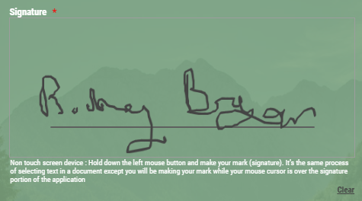
[How do I pay my dues?]

After your application is approved, you will receive an email with the links to the online payment forms

If you this doc did not resolve your issue, please send email to technology@offc.org

